- Copyright for test papers and marking guides remains with West Australian Test Papers.
- The papers may only be reproduced within the purchasing school according to the advertised conditions of sale.
- Test papers must be withdrawn after use and stored securely in the school until 15th June.

PHYSICS

UNITS 1

2023

Insert School Logo

Name: _______________________________________________________

Teacher: ___________________________________________________

TIME ALLOWED FOR THIS PAPER

Reading time before commencing work: Ten minutes
Working time for the paper: Three hours

MATERIALS REQUIRED/RECOMMENDED FOR THIS PAPER

To be provided by the supervisor:
- This Question/Answer Booklet; Formula and Constants sheet

To be provided by the candidate:
- Standard items: pens, pencils, eraser or correction fluid, ruler, highlighter.

- Special items: Calculators satisfying the conditions set by the SCSA for this subject.

IMPORTANT NOTE TO CANDIDATES
No other items may be taken into the examination room. It is your responsibility to ensure that you do not have any unauthorised notes or other items of a non-personal nature in the examination room. If you have any unauthorised material with you, hand it to the supervisor before reading any further.

Structure of this paper

Section | Number of questions available | Number of questions to be answered | Suggested working time  (minutes) | Marks available | Percentage of exam
Section One:  Short answer | 11 | 11 | 50 | 54 | 30
Section Two:  Extended answer | 6 | 6 | 90 | 90 | 50
Section Three:  Comprehension  and data analysis | 2 | 2 | 40 | 36 | 20
 |  |  | Total | 180 | 100

Instructions to candidates

- The rules for the conduct of Western Australian external examinations are detailed in the Year 11 Information Handbook 2017. Sitting this examination implies that you agree to abide by these rules.

- Write your answers in this Question/Answer Booklet.

- When calculating numerical answers, show your working or reasoning clearly. Give final answers to three significant figures and include appropriate units where applicable.

When estimating numerical answers, show your working or reasoning clearly. Give final answers to a maximum of two significant figures and include appropriate units where applicable.

- You must be careful to confine your responses to the specific questions asked and follow any instructions that are specific to a particular question.

- Spare pages are included at the end of this booklet. They can be used for planning your responses and/or as additional space if required to continue an answer.
  - Planning: If you use the spare pages for planning, indicate this clearly.
  - Continuing an answer: If you need to use the space to continue an answer, indicate in the original answer space where the answer is continued, i.e. give the page number. Refer to the question(s) where you are continuing your work.

Section One: Short response 30% (54 Marks)

This section has eleven (11) questions. Answer all questions. Write your answers in the space
provided. Suggested working time for this section is 50 minutes.

Question 1 (4 marks)
A student has been given four (4) identical glass balls which have been labelled A, B, C and D. The student knows that the glass balls A, B and C have been given an electric charge – but they do not which type of charge. The student is given the task of identifying the charge on each ball.
The student is given some silk and they rub ball D with this material. They know that this process will transfer electrons from the ball to the silk.

The student uses ball D to exert electrostatic forces on the other three glass balls. The results are summarised below:
Ball D attracts Ball A
Ball A repels Ball B
Ball B attracts Ball C

On the diagram below, indicate the charge on each ball. In the space below, explain how you arrived at this answer.
Ball D
Ball C
Ball A
Ball B

____________________________________________________________________________________________________________________________________________________________________________________________________________________________________________________________________________________________________________________________________________________________________________________________________________________________________________________________________________________

Question 2 (7 marks)

The incomplete nuclear equation below shows a particular fission reaction – including the energy released.

$${}_{92}^{235}{U+{}_{0}^{1}{n→}}___________+{}_{36}^{92}{Kr+3 {}_{0}^{1}{n+173.2 MeV}}$$

The masses of the particles in this reaction are listed below:

U-235 | 235.04393 u
Kr-92 | 91.92616 u
neutron | 1.00867 u

- Identify the missing particle. Include its chemical symbol; mass number; atomic number.
(2)

____________________________

- Convert the energy released in this fission reaction to a ‘mass equivalence’ in atomic mass units (u). Give this answer to five (5) significant figures.
(3)

Answer: _____________ u

- Use your answer from part b) and the particle masses listed to calculate the mass of the missing particle.
(2)

Answer: _____________ u
Question 3 (6 marks)

A toaster, lamp and heater are connected to the same power board which has a safety switch with maximum loading of 15 A. They are connected as shown below:
15 A safety switch

240 V
DC

Heater
Toaster
Lamp

The table below shows the power rating and/or resistance for each appliance.

APPLIANCE | POWER RATING (W) | RESISTANCE (Ω)
TOASTER | 1.10 x 10³
LAMP | 0.0600 x 10³
HEATER |  | 23.4

- Calculate the power consumed by the heater when it is operating. Place the value in the table; show working below.
(2)

- By use of a calculation, determine if the circuit breaker will be tripped when all appliances are operating.
(4)

Question 4 (4 marks)

Thermal insulation in the form of rectangular batts can be laid on top of the ceiling in the roof cavity of home to help reduce heat transfer. A photograph of this material is shown below left.

Glass fibres and air pockets
Reflective ‘wall wrap’
Reflective ‘wall wrap’

The batts are made in the following way:

The insulation is constructed from very thin glass fibres that, once packed into the batt, creates millions of air pockets. This material is then covered on each side by reflective ‘wall wrap’ that resembles aluminium foil. See diagram above right.

In terms of methods of heat transfer, explain how the following components reduce heat loss (write you answers in the table provided).

Trapped air pockets:

______________________________________________________________________________________________________________________________________________________________________________________________________________________________________________________________________________________________________________________________________________________________________________________________________

Reflective ‘wall wrap’:

______________________________________________________________________________________________________________________________________________________________________________________________________________________________________________________________________________________________________________________________________________________________________________________________________

Question 5 (4 marks)

A group of Physics students creates the circuit shown below. Each of the four (4) resistors have an equal resistance ‘R’. The ammeter registers a current of 4.00 A; the battery has a potential difference of 12.0 V. The resistance of the wires and the battery’s internal resistance can be assumed to be negligible.

A

R
R

R
R

Calculate the value of ‘R’.

Answer: ____________Ω

Question 6 (5 marks)

A residual current device (RCD) protects both the home from excess currents and consumers from electrocution. It is mandatory for all new houses to have an RCD in their meter box.

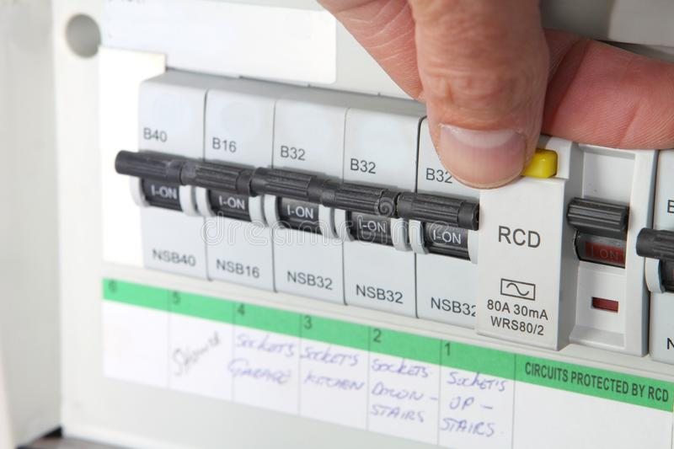
From https://www.dreamstime.com/photos-images/rcd.html

- There are three wires in the household circuit: active, neutral and earth. On which wire(s) must the RCD be placed? Explain.
(2)

______________________________________________________________________________________________________________________________________________________________________________________________________________________________________________________________________________________________________________________________________________________________________________________________________
- The picture below shows a situation where an RCD will protect a consumer. In this situation, a person is accidentally touching an active heating element with a metal knife as they try to extract some toast that has become stuck in the toaster. The toaster is NOT turned off.

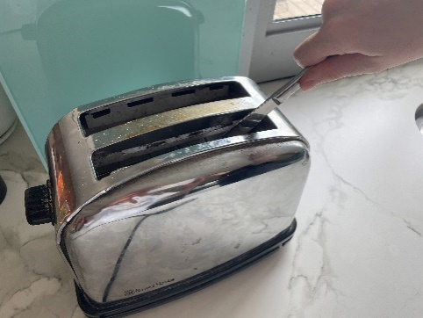

Explain why an RCD will protect the consumer here, but a safety switch or fuse will not.
(3)
______________________________________________________________________________________________________________________________________________________________________________________________________________________________________________________________________________________________________________________________________________________________________________________________________
Question 7 (4 marks)

The diagram below shows the basic structure of a fission reactor core.
Fuel Rod
Control Rod

Heavy Water Moderator

Concrete Shield

State whether the power output of the fission reactor would ‘increase’; ‘decrease’; or ‘stay the same’ in each of the scenarios described (circle the correct answer). Provide a brief explanation for your choice in the space provided:

- the control rods are extracted from the reactor core.
(2)

INCREASE / DECREASE / STAY THE SAME

________________________________________________________________________________________________________________________________________________________________________________________________________________________________________________________________________________________________________________________
- the heavy water moderator accidentally completely drains out of the reactor core via a leak.
(2)

INCREASE / DECREASE / STAY THE SAME

________________________________________________________________________________________________________________________________________________________________________________________________________________________________________________________________________________________________________________________

Question 8 (5 marks)

An ice cube at -1.30°C was placed into a glass with a mass of 155 g containing 105 g of water at 45.0°C. In one minute, the ice cube had melted. The final mass of water in the glass was 125 g and the final temperature of the water was 31.3°C.

Use the above data to calculate an experimental value for the specific heat capacity of the glass.

Answer: ______________ J kg⁻¹

Question 9 (4 marks)

As more ice was added to the glass in Question 8, a layer of water formed on the outside of the glass. Name this phenomenon and briefly explain how it happens.

______________________________________________________________________________________________________________________________________________________________________________________________________________________________________________________________________________________________________________________________________________________________________________________________________________________________________________________________________________________________________________________________________________________________________________________________________________________________________________________________________________________________________________________________

Question 10 (6 marks)

The diagram below shows the parts of a fuel gauge assembly in a car.
Variable Resistor
Float
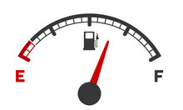
Fuel Gauge/Ammeter
Fuel Tank
-
+
Metal Pivot
12 V Car Battery
Sliding Contact
Fuel

- The sliding contact touches the exposed wire on the variable resistor. The closer the contact is to the top of the variable resistor, the greater its overall resistance.
- The sliding contact is attached to a float which sits on the surface of the fuel in the tank.
- The sliding contact rotates around a metal pivot to which it is electrically connected.
- The metal pivot is connected by a cable to the positive terminal of the 12 V car battery.
- The fuel gauge acts as an ammeter which is connected to the negative terminal of the 12 V car battery and the variable resistor by cables.
- As the petrol level changes, the sliding contact rotates upwards and downwards
around the metal pivot.

- Draw a circuit diagram using standard circuit symbols for the fuel gauge assembly above.
(2)

- Using Physics concepts from the Electricity Topic, describe how the fuel gauge assembly works.
(4)

____________________________________________________________________________________________________________________________________________________________________________________________________________________________________________________________________________________________________________________________________________________________________________________________________________________________________________________________________________________
Question 11 (5 marks)

In the future, nuclear physicists are hoping to create fusion energy using an isotope of Helium (He-3). Whilst Helium-3 is very rare on Earth, missions to the Moon have revealed that the lunar surface is a very rich reservoir of this isotope. Scientists believe that mining this material will be possible and will create an abundant fusion fuel on Earth.

The diagram below illustrates the fusion reaction between Helium-3 and Deuterium (H-2).
Deuterium
Helium-3

Proton
Helium-4

- Write a balanced nuclear equation for the above fusion reaction.
(2)

The nuclear masses of the particle involved in this fusion reaction are as follows:

Helium-3 | 5.0368035 x 10⁻²⁷ kg
Deuterium | 3.5296285 x 10⁻²⁷ kg
Helium-4 | 6.6843420 x 10⁻²⁷ kg
Proton | 1.6821409 x 10⁻²⁷ kg

- Calculate the energy released (in Joules) by one of these fusion reactions.
(3)

Answer: _____________ J

Section Two: Problem-solving 50% (90 Marks)

This section has six (6) questions. You must answer all questions. Write your answers in the
space provided. Suggested working time for this section is 90 minutes.

Question 12 (13 marks)

The graph below shows how the current (mA) flowing thought a light globe varies as the potential difference (V) applied to it increases.
I (mA)
750

500
250
0.700
0.600
0.500
0.400
0.300
0.200
0.100
0.800
PD (V)

- State the potential difference range within which the globe acts a non-ohmic conductor. As part of your answer, define what is meant by an ohmic conductor.
(2)

__________________________________________________________________________________________________________________________________________________________________________________________________________________________________________

- Calculate the electric power consumed by the globe when it carries a current of 250 mA. Show clearly how you did this.
(3)

Answer: ______________ W
- Calculate the resistance (in Ohms) of the globe when it has a potential difference of 0.600 V applied to it. Show working.
(3)

Answer: _____________ Ω

- Calculate the number of electrons that flow through the light globe in one (1) minute when it has a potential difference of 0.240 V applied to it.
(3)

Answer: ____________________ electrons

- Calculate how much electrical work is done on each electron when the light globe has a potential difference of 0.500 V applied to it.
(2)

Answer: _______________ J

Question 13 (17 marks)

A group of students perform an experiment where they are asked to identify three unknown liquids. The liquids are all colourless; have very similar densities; and can be considered to have the same thermal conductivity.

The three liquids are listed in the table below with two of their thermal properties – specific heat capacity and melting point:

LIQUID | SPECIFIC HEAT CAPACITY (J kg⁻¹ °C⁻¹) | MELTING POINT (°C)
ETHYL ETHER | 2220 | -115
PROPYLENE | 2800 | -60
ETHANOL | 2800 | -115

The students are provided with 2.00 x 10⁻¹ kg of each liquid and have access to a freezer which can operate anywhere between -10.0 °C and -1.50 x 10² °C.

- Describe how the students could design an experiment to distinguish between propylene and the other two liquids. Explain how the thermal properties of the liquids are utilised in this experiment.
(3)

______________________________________________________________________________________________________________________________________________________________________________________________________________________________________________________________________________________________________________________________________________________________________________________________________
- Describe how the students could design an experiment to distinguish between ethyl ether and ethanol. Again, explain how the thermal properties of the liquids are utilised in this experiment.
(4)

__________________________________________________________________________________________________________________________________________________________________________________________________________________________________________________________________________________________________________________________________________________________________________________________________________________________________________________________________________________________________________________________________________________________________
The freezer cools the liquids at a constant rate. The graph below shows the cooling curve for propylene as it cools from a room temperature of 20.0 °C to its freezing point. The coordinate for the end point of the curve is labelled on the graph. The quantity of heat lost by the liquid (in kJ) as it cools is plotted on the x-axis.

HEAT ENERGY ADDED v TEMPERATURE OF LIQUID

-80.0
-60.0
-120.0
-100.0
-40.0
-20.0
80.0
20.0
T (°C)
10.0 |  | 20.0 | 40.0  30.0 |  | 50.0 |  | 60.0  70.0
 |  |  |  |  |  |  | Q (kJ)
 |  | PROPYLENE
 |  |  |  |  | (44.8, -60.0)

- On the graph, add the cooling curve for ethanol initially at 20.0 °C until it reaches its freezing point. Clearly label the graph and include a coordinate for its end point. Show any working below.
(4)

- Now add the cooling curve for ethyl ether at 20.0 °C until it reaches its freezing point. Again, clearly label the graph and show any working below.
(3)

- If the propylene continued to lose internal energy via heat loss, describe the shape of the graph immediately after it had reached its freezing point. Explain your answer in terms of internal energy.
(3)

____________________________________________________________________________________________________________________________________________________________________________________________________________________________________________________________________________________________________________________________________________________________________________________________________________________________________________________________________________________

Question 14 (13 marks)

A group of Physics students constructed the circuit below. In addition to the five (5) resistors in the circuit, two switches S₁ and S₂ are inserted. These are located in the positions shown below.
12 V
S₁
S₂
5.00 Ω
4.00 Ω
10.0 Ω
10.0 Ω

5.00 Ω

- With clear working shown, calculate the current drawn from the 12 V power supply when:

- S₁ is closed and S₂ is open.
(4)

Answer: ____________ A

- both S₁ and S₂ are closed.
(4)

Answer: _______________ A

- The 4.00 Ω resistor has a power rating of 4.00 W. Is this exceeded when S₁ and S₂ are closed? Show via a calculation.
(5)

Question 15 (14 marks)

Chlorine-36 is naturally occurring radioisotope that is mainly formed in the earth’s atmosphere when Argon-36 atoms collide with cosmic rays and decay. The half-life of Cl-36 is 3.00 x 10⁵ years; its atomic mass is 36.9763 u; and it is a beta (β⁻) emitter.

Atmospheric Cl-36 atoms mix with other chlorine isotopes in the atmosphere and reach the earth when it rains. It mixes with groundwater and, therefore, is part of a radiometric process for determining the age of groundwater.

The mass of a proton is 1.00727 u; the mass of a neutron is 1.00867 u.

- Write a balanced nuclear equation for the beta decay of Cl-36.
(3)

- Use the data above to determine the binding energy per nucleon for a Cl-36 nuclei.
(4)

Answer: _____________ MeV per nucleon

Ground water is normally dominated by dissolved deposits of Sodium, Calcium, Chlorine and Sulphate ions. The Chlorine deposits include its stable isotopes as well as the radioisotope, Cl-36. In fresh groundwater, the ratio of Cl-36 nuclei to Chlorine nuclei is measured to be 343 x 10⁻¹⁵ : 1. In a particular sample of groundwater found in the Eastern Desert in Egypt, this ratio has been reduced to 5.00 x 10⁻¹⁵ : 1.

- Explain why the Cl-36 to Chlorine ratio has reduced in the groundwater from the Eastern Desert.
(3)
________________________________________________________________________________________________________________________________________________________________________________________________________________________________________________________________________________________________________________________

- Using the information from part c) about the Cl-36 to Chlorine ratio, estimate the age of the groundwater in the Eastern Desert.
(5)

Answer: ________________ years

Question 16 (21 marks)

Some physicists conducted an experiment to investigate the expansion of metals as they are heated. They utilised the equipment represented in the diagram below.

A large tank is filled with water of a known temperature (T₂) and a metal bar of length 10.0 m is immersed in it. The bar has been kept in a refrigerated space and its temperature before immersion (T₁) is measured to be 10.0 °C. After some time, the expansion of the metal bar is observed by measuring the length that it is extended (∆L).
∆L
L₀
TANK
METAL BAR

WATER

It is known that the expansion of the bar is given by the following formula:
∆L = α . L₀ (T₂ – T₁)

Where: ∆L = extension in length due to expansion (m)
α = coefficient of linear expansion
L₀ = original length of the metal bar prior to heating (m)
T₂ = final temperature of metal after heating (°C)
T₁ = starting temperature of met before heating (°C)

The value of the ‘coefficient of linear expansion” (α) is unique to a material. Some values of ‘α’ for some common metals are shown below:

Table 1: Coefficients of Linear Expansion

MATERIAL | α ( ________________ )
COPPER | 5.1 x 10⁻⁵
STEEL | 1.3 x 10⁻⁵
ALUMINIUM | 2.2 x 10⁻⁵
BRASS | 1.9 x 10⁻⁵

The physicists conducted their experiment and collected the following data (some data is missing):

Table 2: Data from the Expansion Experiment

T_{i} (°C) | T_{f} (°C) | ∆T (°C) | ∆L (x 10⁻³ m)
10.0 | 20.0 | 10.0 | 1.3
10.0 | 40.0 |  | 3.9
10.0 |  | 50.0 | 6.5
10.0 | 80.0 | 70.0 | 9.1
10.0 | 100.0 | 90.0 | 11.7

- In terms of the kinetic particle model, explain why a metal bar expands as it is heated.
(3)

______________________________________________________________________________________________________________________________________________________________________________________________________________________________________________________________________________________________________________________________________________________________________________________________________
b) Explain why the coefficient of expansion is the same value for the metal bar no matter what dimension it’s change in length is measured in.
(3)

______________________________________________________________________________________________________________________________________________________________________________________________________________________________________________________________________________________________________________________________________________________________________________________________________
c) Complete Table 2 by calculating the missing values. Use the space below for any working out.
(2)

d) The units for ‘α’ are missing from the table at the top of the second column in Table 2. Write down the units for this quantity in the space provided.
(2)

e) On the grid on page 25, plot ‘∆L’ against ‘∆T’. Place ‘∆L’ on the y-axis. Draw a line of best fit for this data.
(4)

f) Calculate the gradient of the line of best fit. Include units in your answer.
(4)

Gradient: _______________

Units: _______________

g) Hence, use the information provided in table 2 to identify the metal in the experiment.
(3)

________________________



Question 17 (12 marks)

During the production of paper, large lengths are pulled off a roll for cutting packaging. During this process, the paper rubs against machine parts and large negative static charges can be produced. This can prevent the paper from rolling out smoothly and efficiently.

To remove this excess negative charge, devices called static eliminators are used. In one design, the alpha radiation from Polonium-210 is used. The Polonium-210 is stored in a ‘bar’ which directs alpha radiation towards the paper as it rolls underneath. The diagrams below illustrate this arrangement.

STATIC ELIMINATOR
PAPER ROLL

ALPHA RADIATION

CHARGED PAPER

DIAGRAM 1: SIDE-ON VIEW

STATIC ELIMINATOR
CHARGED PAPER
ALPHA RADIATION

DIAGRAM 2: FRONT-ON VIEW

- Describe how the paper gains a negative charge as it rubs against the machinery.
(3)

________________________________________________________________________________________________________________________________________________________________________________________________________________________________________________________________________________________________________________________

- Write the decay equation for Polonium-210.
(3)

- Explain why alpha particles are able neutralise the paper. As part of your answer, explain why beta and gamma radiation would be unable to perform this task.
(4)

____________________________________________________________________________________________________________________________________________________________________________________________________________________________________________________________________________________________________________________________________________________________________________________________________________________________________________________________________________________
- Describe the distance that the static eliminator would need to be placed from the paper to effectively neutralise the paper. Assume that the air conditions are ambient. Briefly explain your answer.
(2)

________________________________________________________________________________________________________________________________________________________________________________________________________________________________________________________________________________________________________________________

Section Three: Comprehension 20% (36 Marks)

This section contains two (2) questions. You must answer both questions. Write your answers in
the spaces provided. Suggested working time for this section is 40 minutes.

Question 18 (18 marks)

Thyroid cancer is relatively common and treatable form of cancer. The thyroid is a gland located at the base of the neck near the Adam’s Apple. The thyroid gland secretes a hormone that is responsible for the body’s energy levels, metabolism, heart rate and blood pressure – amongst other things. The thyroid gland also absorbs nearly all of the iodine in the human body.

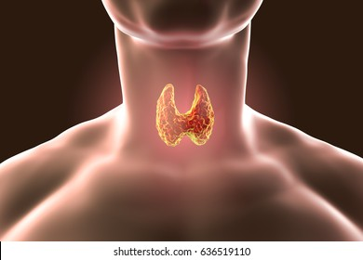

Iodine-131 (known as RAI, or radioactive iodide) is a beta-minus emitting radioisotope with a half-life of eight (8) hours. Capsules of RAI can be swallowed and will dissolve in the stomach. RAI is then released into the blood stream, will travel around the body, and finally collect in the thyroid gland.

This treatment is normally used once most of the malignant thyroidal tissue has been removed via surgery. The RAI that collects in the thyroid can be used to destroy any remaining cancerous tissue.

A radioisotope that is introduced into the human body can have undesirable side effects; hence, the mass of RAI introduced and body radiation levels must be monitored and maintained at a safe level. RAI therapy is considered safe if the absorbed dose in the blood is <2 Gy. In addition, whole body retention levels of radiation must be a maximum of 4.4 GBq after 48 hours.
(Note – 1 Bq = 1 decay s⁻¹).

Usually, RAI is introduced in stages: 1.1-3.7 GBq is introduced in the first RAI therapy; higher amounts are introduced for subsequent therapies but are usually limited to 7.4 GBq.

The amount of RAI in a human’s body after therapy is usually very small and reduces relatively quickly. Hence, there is probably limited danger to others due to the radiation emitted from a patient. However, it is good medical practice to reduce the exposure to others by undertaking the following as a patient undergoing therapy:

- Maintain a reasonable distance from others.
- Limit contact time with others.
- Most RAI will leave your body in urine; so, good hygiene is good practice in reducing exposure. Also, drink lots of water – this will help expel RAI more quickly form the body.
In most cases, normal activities can be resumed by patients after 72 hours.

  - Write the symbol (include both atomic and mass numbers) for the daughter isotope resulting from the beta-decay of Iodine-131.
(2)

  - RAI is a beta-emitter. This property makes this radioisotope suitable for this type of therapy. Explain why.
(3)

______________________________________________________________________________________________________________________________________________________________________________________________________________________________________________________________________________________________________________________________________________________________________________________________________
  - Use your Physics knowledge to explain this statement: “RAI therapy is considered safe if the absorbed dose in the blood is <2 Gy.”
(3)

______________________________________________________________________________________________________________________________________________________________________________________________________________________________________________________________________________________________________________________________________________________________________________________________________
d) Calculate the absorbed dose required for an alpha emitter so that it causes the same dose equivalent (in Sv) as the RAI when the absorbed dose in the blood is 2.00 Gy.
(3)

Answer: _________________ Gy

e) If the activity of RAI in the human body is 4.4 GBq for a total of one (1) minute, calculate the number of beta decays that occur during this time.
(2)

Answer: _________________ decays

f) “In most cases, normal activities can be resumed by patients after 72 hours.” Explain this statement with the use of a calculation.
(3)
____________________________________________________________________________________________________________________________________________________________________________________________________________________________________________________________________________________________________________________________________________________________________________________________________________________________________________________________________________________
g) One particular patient has a measured radiation activity of RAI in their body equal to 4.4 GBq. Calculate the activity of RAI in their body 48 hours earlier.
(2)

Answer: ______________ GBq

Question 19 (18 marks)

How do car radiators work?

A car needs kinetic energy to move – this is provided by the energy transformations that occur when a car’s fuel undergoes combustion in its engine. This combustion causes the parts of the engine to move which, in turn, causes the axles and wheels to turn.

The movement of engine parts can produce an enormous amount of heat which, if not removed, can cause extensive (and expensive!) damage to the engine itself. Modern engines are made out of aluminium; a six (6)-cylinder engine can have a mass as high as 204 kg. The optimal operating temperature of a typical engine is 91°C; however, at a temperature above 93°C, the engine is considered to be ‘overheating’ – and heat energy needs to be removed to reduce this temperature.

Engines, therefore, have cooling systems which consist of a radiator (see Figure 1 below); a liquid coolant that is pumped around the engine; hoses to circulate the coolant; a heat pump; and a thermostat that monitors coolant temperature. The coolant travels from the radiator to the engine where it absorbs excess heat energy, and then returns via more hoses to the radiator for cooling before reuse.
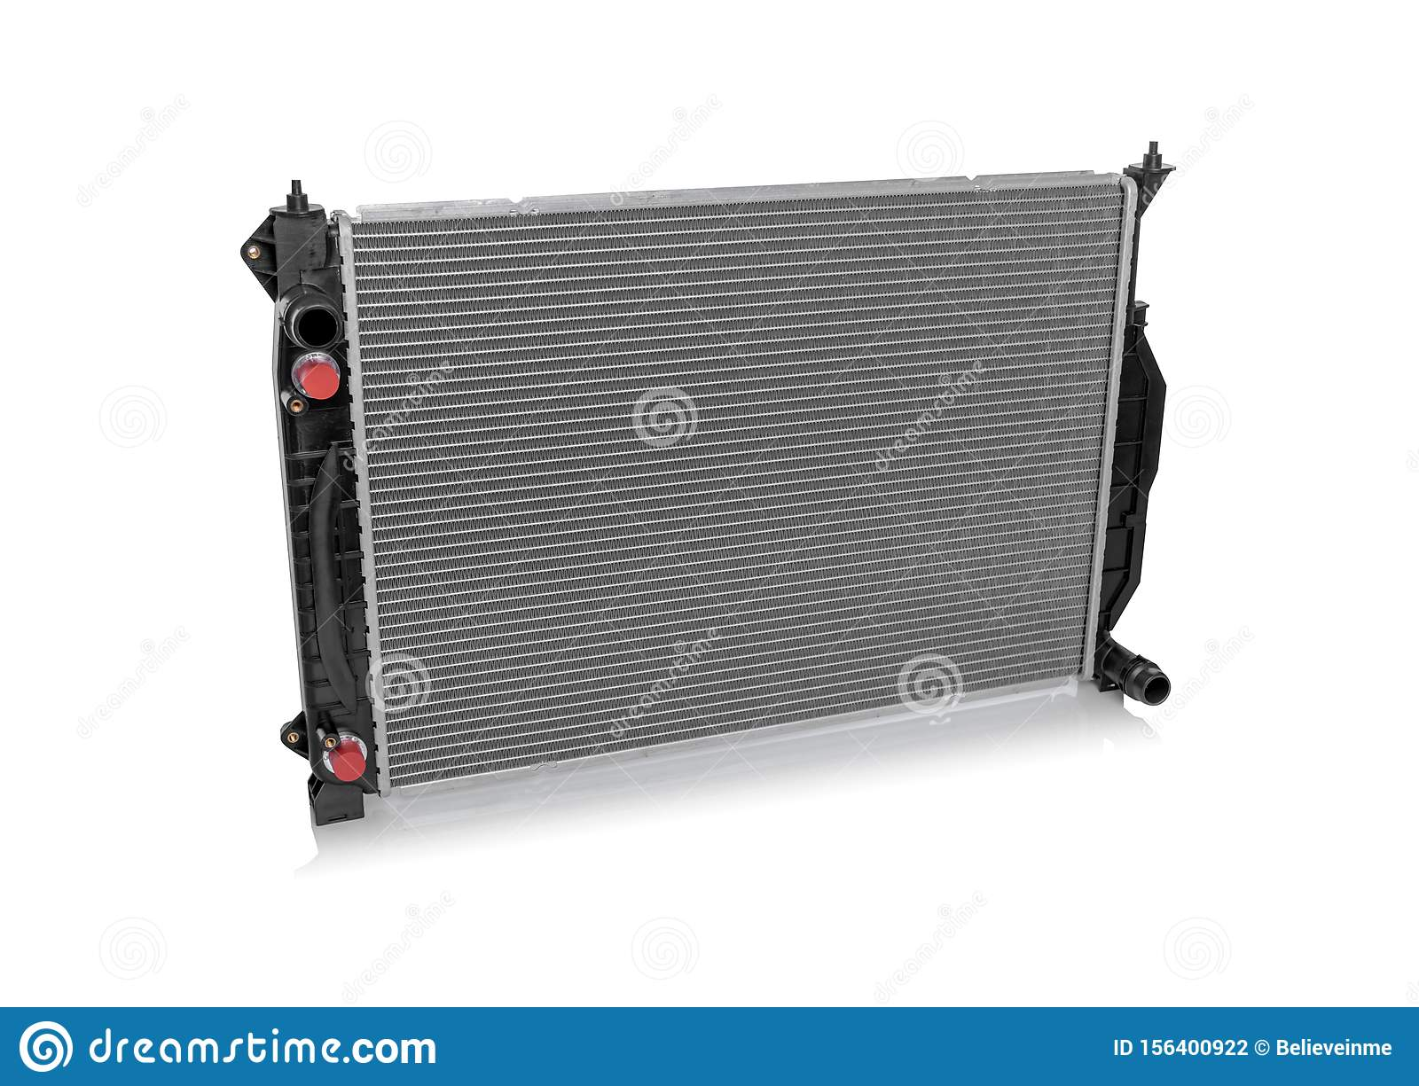
Figure 1: Car radiator
The car radiator is made of aluminium and is situated at the front of the car - at the front of the engine itself. It has three (3) major components: the core, the pressure cap; and the inlet/outlet tanks.
The core is the main section of the radiator. It is a large metal block with rows of narrow metal fins (see Figure 2 below).
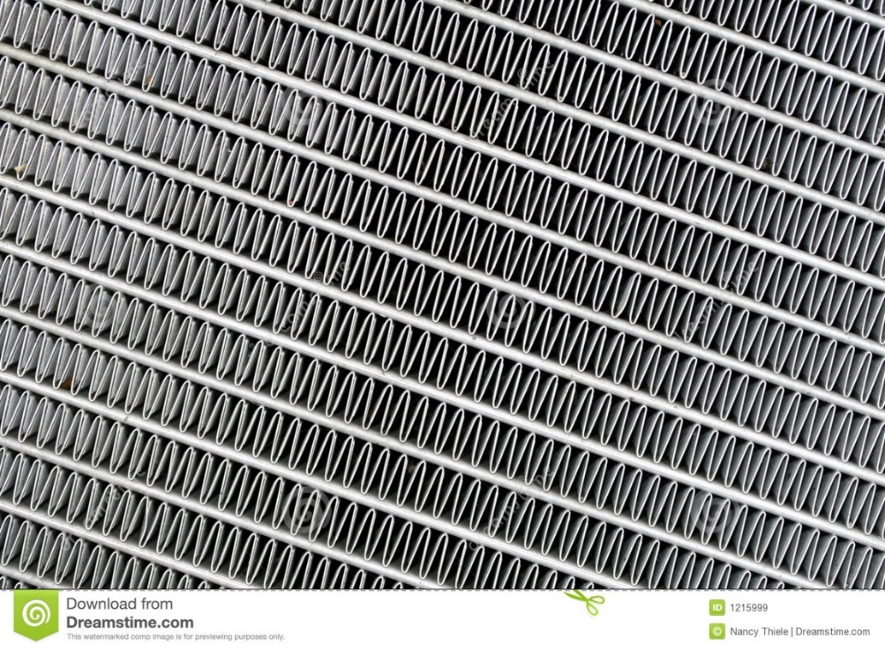
Figure 2: Car radiator – metal fins
The metal fins are in contact with tubes (which are located inside the fins). These tubes carry the coolant through the metal fins.
The core is where the hot coolant that has passed through the engine releases its heat energy and cools for its next trip around the heat-exchange circuit. As the car moves forward, air passes over the thin metal fins extracting heat energy from the radiator. A fan blows this hot air out of the engine.
To increase the rate of the heat exchange process, the tubes inside the fins have a spiral-shaped piece of metal inside them called a ‘turbulator’. The turbulator stirs the coolant inside the tubes and increases its overall turbulence as it travels through the fins (see Figure 3 below).
Coolant passes through tube and is stirred as it passes around the turbulator
tube inside metal fin
turbulator

Figure 3: Turbulator stirring coolant as it passes through the tubes inside the metal fins
This has the effect of causing the amount of liquid coolant coming into contact with the tubes inside the metal fins to increase, thereby increasing the rate of heat transfer and cooling.
The coolant itself consists of a 50% water – 50% antifreeze mixture. Antifreeze typically consists of ethyl glycol, which has a specific heat capacity of 2.78 x 10³ J kg⁻¹ K⁻¹, and a boiling point of 197 °C. The coolant, therefore, acts as if it is a liquid with a specific heat capacity halfway between water and ethyl glycol.

The antifreeze helps regulate the engine’s temperature during extreme conditions – in both very hot and very cold conditions. As the temperature outside changes from hot to cold, for example, less coolant is pumped throughout the engine to maintain a constant operating temperature.

- Apart from combustion of fuel, describe the other energy transformation that creates the excess heat that is produced in a car engine.
(2)

____________________________________________________________________________________________________________________________________________________________________________________________________________________________________________________________________________________________________________________________________________________________________________________________________________________________________________________________________________________

- Aluminium has a specific heat capacity of 9.00 x 10² J kg⁻¹ K⁻¹. Using information from the article, calculate the amount of thermal energy absorbed by the radiator in a modern six-cylinder engine as it has its temperature increased from ‘optimal’ to ‘overheating’.
(2)

Answer: ____________________ J

- The coolant has a specific heat roughly halfway between the values for water and ethyl glycol. Given this, estimate the mass of coolant required to cool a typical aluminium engine from 104 °C to 93 °C. Assume that the coolant starts at an ‘optimal’ temperature of 91 °C and extracts all the heat energy lost by the engine.
(4)

Answer: ________________ kg

To compensate for the enormous amount of coolant required to keep an engine from overheating, the coolant is continually circulated in the radiator.

d) Using information from the article, explain the heat transfer processes involved in removing excess heat energy from the hot coolant to the car’s surroundings.
(4)

____________________________________________________________________________________________________________________________________________________________________________________________________________________________________________________________________________________________________________________________________________________________________________________________________________________________________________________________________________________
e) Explain why the ‘turbulator’ is able to increase the rate of heat exchange from the coolant to the radiator.
(2)

______________________________________________________________________________________________________________________________________________________________________________________________________________________________________________________________________________________________________________________________________________________________________________________________________
f) The coolant is made of two main components (ie – liquids), each with a thermal property that benefits how effectively the coolant works. State these two (2) properties and describe how each property increases the overall effectiveness of the coolant.
(4)

____________________________________________________________________________________________________________________________________________________________________________________________________________________________________________________________________________________________________________________________________________________________________________________________________________________________________________________________________________________
End of Questions

Additional working space

Additional working space

Spare grid for graph

End of examination
Acknowledgements

Question 6 Image from https://www.dreamstime.com/photos-images/rcd.html

Question 9 Image from https://www.publicdomainpictures.net/en/stock-photos.php?hleda=fuel+gauge

Question 17 Image from https://www.shutterstock.com/search/thyroid-gland

Question 18 Image from https://www.dreamstime.com/car-radiator-isolated-car-radiator-isolated-white-background-image156400922

Image from https://www.dreamstime.com/royalty-free-stock-images-car-radiator-abstract-image1215999

